**Project Design Phase-II**

**Data Flow Diagram & User Stories**

|  |  |
| --- | --- |
| Date | 20 October 2022 |
| Team ID | PNT2022TMID24356 |
| Project Name | Project – News Tracker Application |
| Maximum Marks | 4 Marks |

**Data Flow Diagrams:**

A Data Flow Diagram (DFD) is a traditional visual representation of the information flows within a system. A neat and clear DFD can depict the right amount of the system requirement graphically. It shows how data enters and leaves the system, what changes the information, and where data is stored.

Example: DFD Level 0 (Industry Standard)

**Example:** [**(Simplified)**](https://developer.ibm.com/patterns/visualize-unstructured-text/)

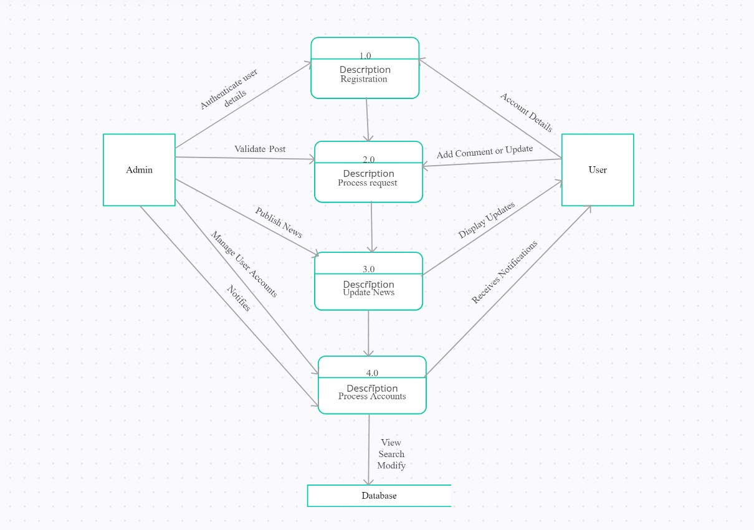

**](https://developer.ibm.com/patterns/visualize-unstructured-text/)**

**User Stories**

Use the below template to list all the user stories for the product.

| **User Type** | **Functional Requirement (Epic)** | **User Story Number** | **User Story / Task** | **Acceptance criteria** | **Priority** | **Release** |
| --- | --- | --- | --- | --- | --- | --- |
| Customer (Mobile user) | Registration | USN-1 | As a user, I can register for the application by entering my email, password, and confirming my password. | I can access my account / dashboard | High | Sprint-1 |
|  | Authentication | USN-2 | As a user, I will receive confirmation email once I have registered for the application | I can receive confirmation email & click confirm | High | Sprint-1 |
|  | Registration with account | USN-3 | As a user, I can register for the application through Facebook | I can register & access the dashboard with Facebook Login | Low | Sprint-2 |
|  | Registration with domain | USN-4 | As a user, I can register for the application through Gmail | I can register & access the mails and promotions with Gmail | Medium | Sprint-1 |
|  | Login | USN-5 | As a user, I can log into the application by entering email & password | I can enter into the website and explore | High | Sprint-1 |
|  | Dashboard | USN-6 | As a user, I can log in into the application dashboard. | I can access my account /  Profile. | Medium | Sprint -2 |
| Customer (Web user) | Login | USN-7 | As a user, first I need to login into my desktop browser. | I can access my account /  Profile. | High | Sprint-3 |
| Customer Care Executive | Registration | USN-8 | As a user, I can register into the website to access the resource. | I can access my account /  Profile. | High | Sprint-2 |
| Administrator | Registration with account | USN-9 | As a user, I can simply register with my Facebook account | I can access my account /  Profile. | Medium | Sprint-1 |
|  | Registration with domain | USN-10 | As a user, I can register to the website with my Gmail account | I can access my account /  Profile. | Medium | Sprint-1 |
|  | Login | USN-11 | As a user, I can Login into the website with my registered account. | I can access my account /  Profile. | High | Sprint-3 |
| Chat Bot | Help Assistant | USN-12 | As a AI Watson Assistant, I can able to create a bot to guide or help the user by passing respective queries. | I can access the database to solve the query of the user. | Low | Sprint-1 |